The E-News is the monthly newsletter of CUHMA, the primary outlet to share news/announcements, upcoming events, abstracts of recent publications, job postings, professional perspectives, and images of relevant professional scenes. Submission of applicable content is welcome. New issues are released on the last business day of each month. Past issues are available at <https://cuhma.ca>. Direct correspondence to [info@cuhma.ca](mailto:info@cuhma.ca).

Neal W. Pollock, PhD

Université Laval

**NEWS/ANNOUNCEMENTS**

**UMC Level 1 Dive Medicine Course Completion**

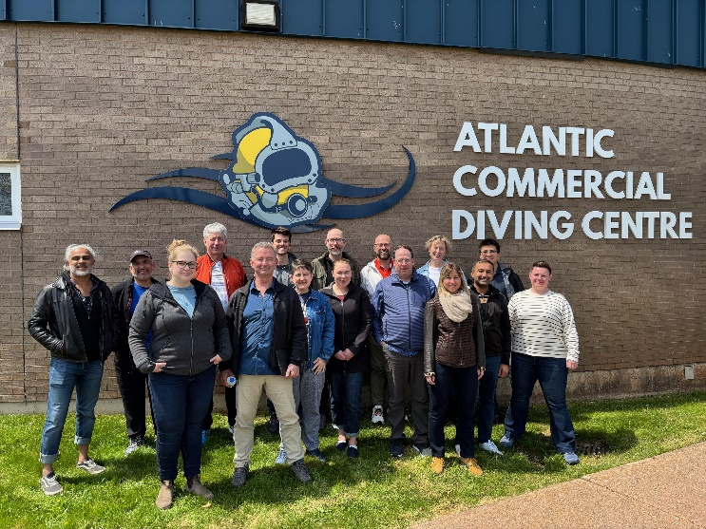

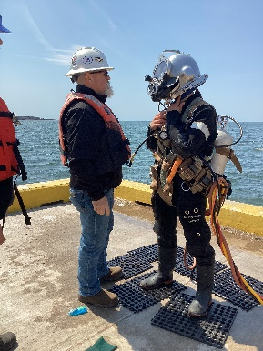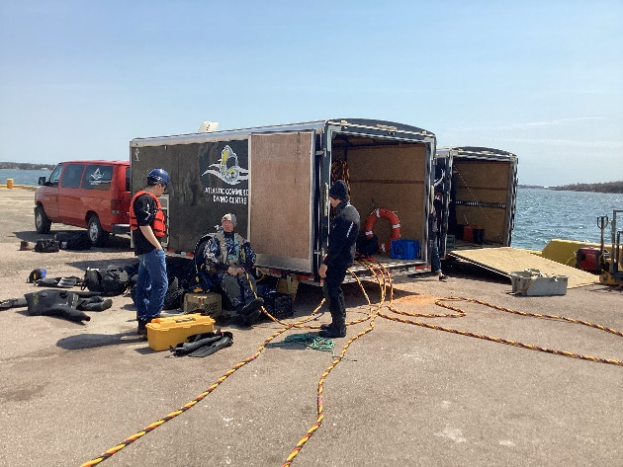

*UMC L1 group; dive trailers with standby diver; and pre-dive surface supply diver.*

Eight physicians, two dentists, and one postdoctoral fellow came from across Canada in May to complete an Undersea Medicine Canada Level 1 course (Fitness to Dive) held at the Atlantic Commercial Diving Centre on Prince Edward Island (<https://atlanticcommercialdivingcentre.com>). The 40-hour program (preceded by an optional five-hour primer session) was designed to meet the CSA Z275.1-22 standards for Level 1 physician training. Participants gained experience through a wide array of lecture, case studies, and close observation of commercial diving equipment and onsite work. Faculty included Drs. Hafeez Jamal, Chris Logue, Debbie Pestell, Neal Pollock, and Geoff Zbitnew.

**UPCOMING EVENTS**

**ICHF Biennial Congress 2025**

The International de Centres Hyperbares Francophones organization represents 40 French hyperbaric units located around the world. The ICHF conference is a biennial event, with the fourth installment held June 08-10 in Quebec, QC. Workshops will be held at Hotel-Dieu de Levis and the main conference events in Vieux Quebec. For details:

<https://association-ichf.org/4ieme-congres-ichf-quebec-2025>.

**EUBS Annual Scientific Meeting 2025**

The annual scientific meeting of the European Underwater and Baromedical Society will be held September 02-06 in Helsinki, Finland. Information will be posted on the dedicated conference website: [www.eubs2025.com](http://www.eubs2025.com).

**Canadian Association of Wilderness Medicine 2025**

CAWM is a non-profit organization with the goal of connecting Canadian practitioners and researchers with an interest in wilderness medicine, and in promoting the field as an area of focus and specialization. The sixth annual conference - Prepared for the Unpredictable: Advancing Medicine in the Wild - will be held October 03-05 in Canmore, AB and virtually in a hybrid format. Visit: <https://cawm.ca/cawm2025-2>.

**Brazilian Congress of Hyperbaric Medicine 2025**

The 10th Brazilian Congress of Hyperbaric Medicine & 2nd Brazilian Congress of Hyperbaric Medicine will be held October 16-18 at the Hotel Laghetto Viverone in the Serra Gaúcha region of Brazil. The conference will address six main areas: maritime medicine, diving, hyperbaric oxygen therapy, safety in maritime environments, safety in hyperbaric environments, and wound care. Visit: <https://sbmh.com.br/evento/10o-congresso-brasileiro-de-medicina-hiperbarica-2o-congresso-brasileiro-de-medicina-maritima>.

**RECENT PUBLICATIONS**

**Hennrikus MT. Recompression chamber utilization at Naval Base Guam: an update. Mil Med. 2025 May 7:usaf170. doi: 10.1093/milmed/usaf170. Online ahead of print.**

Introduction: Since 1971, the US Naval Base Guam recompression chamber (NBGRC) has provided hyperbaric oxygen therapy (HBO2) to primarily treat diving decompression sickness (DCS) but also to treat other indicated medical conditions. In 2017, Rendina et al. last reviewed the NBGRC's utilization. The current paper is an update of the chamber's activity from January 2017 through October 2024 including pre- and post-COVID-19 data. The goal of the current study is to report the diagnoses, treatments, demographic data, and estimated costs when providing HBO2 at NBGRC. This information will potentially assist the Defense Policy Review Initiative plan for future staff and resources. Materials and methods: All cases of HBO2 performed at NBGRC from January 1, 2017, to November 1, 2024 were retrospectively reviewed. Paper and electronic medical records including consents, transport summaries, consult notes, insurance records, and hospital records were abstracted for diagnoses, treatments, and eligibility data. In addition, using the eligibility data and Medicare/Medicaid billing codes, charges for HBO2 services for non-Tricare beneficiaries were determined. Results: From 2017 to 2024, 66 patients underwent 176 HBO2 treatments: 31 civilians (47%); 29 active duty (AD) personnel (44%); and 6 retirees (9%). During the study period, there were 180 HBO2 indications. There were 106 (59%) indications for non-dive diagnoses such as diabetic ulcers and wound therapy; 63 (35%) for DCS; 6 (3%) for arterial gas embolism (AGE); 4 (2%) for carbon monoxide (CO) poisoning; and 1 (1%) for cabin decompression. There were 70 HBO2 indications for decompression illness (DCI) (which includes DCS, cabin decompression, and AGE) from January 2017 to October 2024. Pre-COVID, 2017-2019, there were 42 DCI indications; during COVID, 2020-2021, there were 19 DCI indications; and post-COVID, 2022-2024, there were 9 DCI indications. There was a significant difference in DCI indications pre-COVID (M = 14±4.97) compared to post-COVID (M = 3±0.82); t(2) = 3.13, P=0.044. Total reimbursement for non-Tricare beneficiaries from 2017 to 2024 was $102,274.94. Pre-COVID charges were $56,377.18; during COVID, $29,587.52; and post-COVID, $16,310.24. Conclusion: The primary purpose of NBGRC is to support AD operations. However, the current study demonstrates that the treatment of civilian dive injuries is actually the major utilizer of the recompression chamber. Meticulous billing and collecting of facility fees and physician fees from non-Tricare patients for HBO2 services should be emphasized. The COVID decline in treatments has not rebounded to pre-COVID levels, in large part, because of the decline in the Guam tourism industry. Hyperbaric oxygen therapy treatments are expected to increase as Guam tourism improves. In addition, the upcoming relocation of Marines from Okinawa to Guam will also increase HBO2 treatment numbers. The Defense Policy Review initiative needs to factor in the increase in HBO2 treatments because of both these factors. Although the intent of this article is not necessarily to discuss the impact, it should be emphasized that the Navy undersea community and the utilization of recompression chambers and hyperbaric medicine is a life-saving service. Policy changes and resource allotment should always remember this most important mission.

**Kelly KR, Palombo LJ, Givens AC, Bernards JR, Bennett D. Physical and metabolic requirements of elite military divers. Front Physiol. 2025 May 15:16:1505363. doi: 10.3389/fphys.2025.1505363. eCollection 2025.**

Introduction: The purpose of this investigation was to characterize the physical and physiological profile of elite military divers. Methods: The profile included anthropometric (height, weight, fat free mass, fat mass, percent body fat), performance testing (VO2 max, 3-mile run (4.82 km), 0.5-mile swim (0.8 km), weighted pull-ups, estimated 1-rep max for bench and deadlift, and broad jump) and physiological functioning via the awake response (cortisol, testosterone, and dehydroepiandro-sterone). Results: Anthropometric and performance results presented as MEAN±SE include: age: 28.0±0.5 years; height: 70.7±0.3 in (179.6±0.8 cm); weight: 193.3±2.0 lbs (87.9±0.9 kg); body fat percentage: 18.2±0.6%; VO2 max: 55.3±0.7 mL·kg -1·min-1; bench-press 1RM: 278.7±7.7 lb (126.8±3.5 kg); deadlift 1RM: 397.9±10.6 lb (172.7±4.8 kg). Significant associations were found between anthropometric measures and measures of magnitude in testosterone and DHEA. Physical performance metrics showed significant associations with summary parameters in all salivary hormones, with quartile splits yielding significant differences in absolute DHEA and 1RM deadlift (F (3, 30) = 2.97, p=0.048), AUCg testosterone and broad jump (F (3, 37) = 2.86, p=0.05), and AUCg T:C ratio and 25 lb weighted pull ups (F (3, 35) = 4.66, p=0.008). Linear mixed models revealed a significant effects of evolution/collection time point on AUCg DHEA at time points three (B = -2735.96, t (177.32) = -2.39, p=0.018) and four (B = -3089.92, t (178.97) = -2.7, p=0.008); and on peak testosterone at time point five (B = 28.12, t (215.4) = 2.4, p=0.017) with reference to time point one. Conclusion: The data presented herein indicate there are certain periods of training that elicit significant changes in testosterone and DHEA while cortisol remains stable throughout the training cycle. To our knowledge, this effort is the first to document changes in stress biomarkers over time in elite military divers.

**Kouki N, Messelmani M Moncef A, Guediche NE, Mrissa NF, Gharsallah H, Zaouali J. Brain under pressure: Insights into diving-related lesions: a descriptive study. J Neurol Sci. 2025 May 19:474:123553. doi: 10.1016/j.jns.2025.123553. Online ahead of print.**

Background: Diving-related injuries remain as a significant health threat, when involvement of the central nervous system (CNS). Decompression sickness (DCS), particularly type II involving neurological symptoms, can lead to brain lesions though specific patterns. Objective: This study aims to characterize the clinical and radiological features of brain involvement in diving-related injuries, with a focus on corpus callosum lesions. Methods: We conducted a retrospective study from 2011 to 2023 in the neurology department of a military hospital in Tunis, including divers with acute neurological injuries. Data were collected on diving history, clinical presentations, and radiological findings. MRI protocols included T1, T2, FLAIR, gradient echo, and diffusion-weighted imaging (DWI) sequences. Results: Among 41 enrolled patients, 10 exhibited cerebral involvement, all male professional divers with a mean age of 41 years. Symptoms manifested within 10 min of surfacing in 65.8 % of cases and included sensory-motor deficits, vertigo, and headache. MRI revealed diverse patterns: corpus callosum hyperintensities on T2 FLAIR in five cases, an acute ischemic stroke in one patient, and punctiform or nodular lesions in others. DWI abnormalities suggested both cytotoxic and vasogenic edema. Conclusion: Cerebral DCI presents with variable clinical and radiological patterns. Corpus callosum involvement is a hallmark finding, reflecting its vulnerability to ischemia and vasogenic edema. Early detection through a detailed clinical examination allows targeted follow up and recompression therapy. Future research should focus on integrating clinical and imaging data to identify prognostic factors and improve management strategies.

**Singh D, Chaudhry HS, Mohanty CS, Ashta KK. HBOT an effective adjuvant therapy in the treatment of Bell's palsy: a case series. J Family Med Prim Care. 2025; 14(4): 1561-5. doi: 10.4103/jfmpc.jfmpc_1408_24. Epub 2025 Apr 25.**

Bell's Palsy is characterized by sudden onset facial paralysis due to dysfunction of the facial nerve. While conventional treatments exist, the potential of hyperbaric oxygen therapy (HBOT) in managing this condition remains underexplored. This study aims to evaluate the efficacy of HBOT as an additional intervention in Bell's palsy cases. Seven individuals with Bell's palsy were selected for this study and treated with a combination of standard therapy along with sessions of HBOT. The treatment regimen, frequency of HBOT sessions, and follow-up protocols were standardized across all cases. Following the combined therapy approach, significant improvements were observed in all seven cases. Reduction in facial paralysis, improved muscle strength, and enhanced facial mobility were notable outcomes. Furthermore, compared to historical data on Bell's palsy recovery rates with standard treatment alone, the addition of HBOT seemed to expedite the recovery process. This case series demonstrates promising results regarding the efficacy of HBOT as an adjunct therapy for Bell's palsy. The findings suggest that incorporating HBOT into the treatment protocol for Bell's palsy could potentially enhance facial nerve recovery and overall outcomes. Further research with larger sample sizes and controlled studies is warranted to solidify these preliminary findings and establish HBOT's role in the management of Bell's palsy.

CUHMA-ACMHS is the Canadian voice for the advancement of hyperbaric and diving medicine throughout our country and beyond. Our activities include continuous medical education for physicians, nurses, respiratory therapists and anyone involved in the fields of hyperbaric and diving medicine. We are also promoting dissemination of clinical research, publishing position statements, liaising with related professional associations and government agencies. Our main goal is advocating on behalf of our patients. Our vision is to be the reference for the development and delivery of hyperbaric and diving medicine in Canada and beyond. Our mission is to promote excellence in hyperbaric and diving medicine through leadership in education, promotion of best practices and advocacy for our patients. Our values are excellence, leadership, collaboration, communication, and integrity.

**Canadian Undersea and Hyperbaric Medical Association**

10 Plumtree Place, Portugal Cove-St. Philips,

Newfoundland and Labrador, A1M 3T1

[info@cuhma.ca](mailto:info@cuhma.ca) <https://cuhma.ca>

**Editor:** Neal W. Pollock, PhD - [neal.pollock@kin.ulaval.ca](mailto:neal.pollock@kin.ulaval.ca)

**CUHMA BOARD OF DIRECTORS**

Kaighley Brett President

Geoff Zbitnew Past-President

Caroline Bain Vice-President

Neal Pollock Secretary

Sherri Ferguson Director-at-Large

Cesar Orellana Director-at-Large